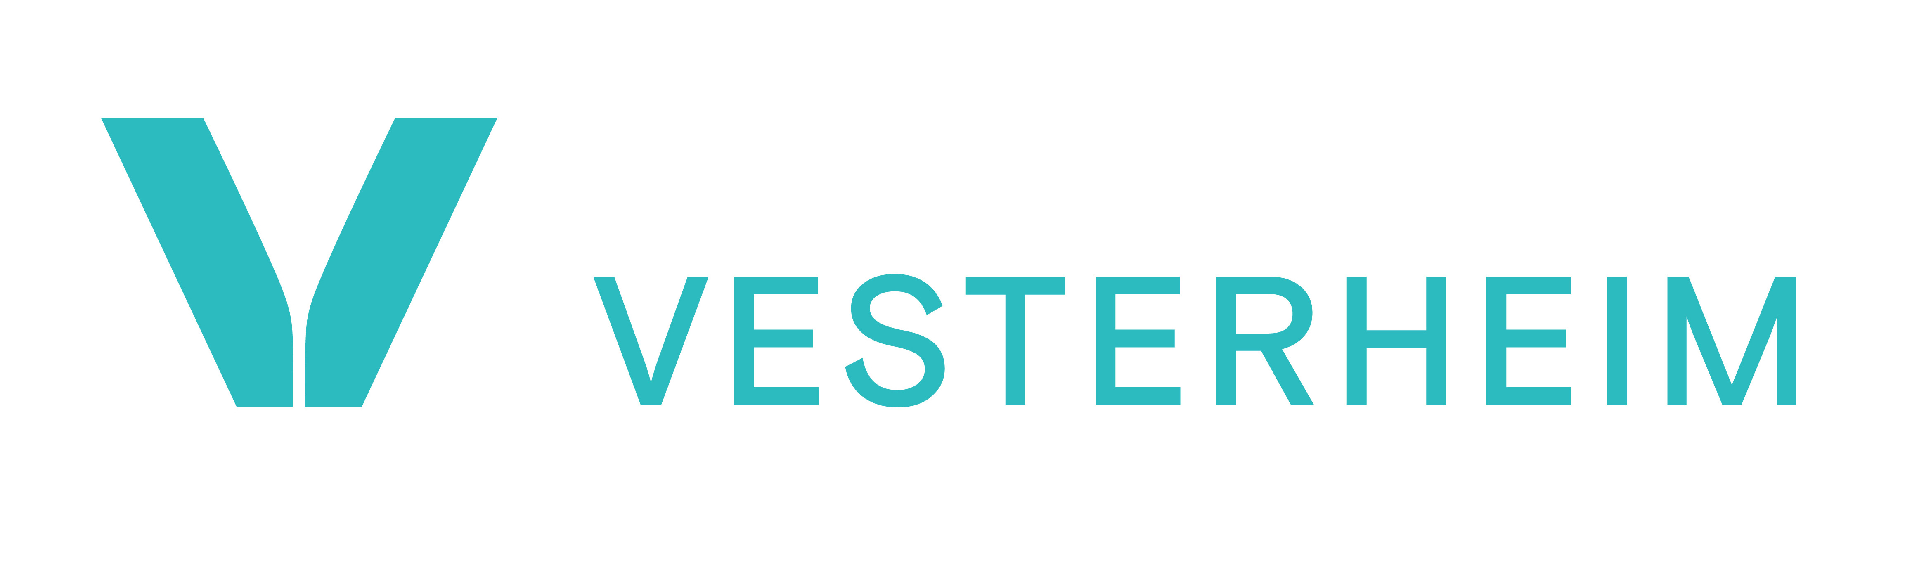

Becky Idstrom, Director of Communications and Marketing
bidstrom@vesterheim.org • 563-382-9681
For Immediate Release

More Info: vesterheim.org/media-kit

Captions for Image:
1: Vesterheim Folk Art School instructor Paul Nyborg tries out the new forges in Vesterheim’s forging studio.
4: Vesterheim Folk Art School instructor Paul Nyborg works in the new Vesterheim forging studio.
5: Alex Clarke tries out the new Vesterheim forging studio with Folk Art School instructors Paul Nyborg and Tom Latané.
6: Vesterheim Folk Art School instructor Paul Nyborg discusses the new Vesterheim forging studio with David Susag.

March 31, 2025

Vesterheim New Forging Studio Opens in May 2025

DECORAH, Iowa — With the completion of a new forging studio at 418 W. Water St., Vesterheim, the National Norwegian-American Museum and Folk Art School, begins an exciting new chapter in metalworking and forging education in Decorah. There will be a ribbon-cutting ceremony for the new studio on Friday, May 16, at 9:00 a.m. at the forge, followed by a reception in Vesterheim Commons. Everyone is welcome! Stay for Vesterheim’s Syttende Mai (Norwegian Constitution Day) celebration after the reception.

The new forging studio includes four propane-fueled forges that accommodate a total of eight students, safety shut-off switches, and a ventilation system that will pump air up and out the west side of the building to ensure that it doesn’t simply recirculate back into the building. There is also a large garage door that opens to a green space behind the building so students can take advantage of being outside.

Knifemaking and forging have always been part of Norwegian and Norwegian-American culture and handcraft. For decades, Vesterheim has worked to ensure that these historic handcrafts are practiced and handed down to future generations by offering classes.

Andrew Ellingsen, Director of Folk Art Education at Vesterheim, said, “We are excited to see the traditional Scandinavian handcrafts of metalworking and forging move into their new home – their own safe forging studio! We have missed offering on-site forging classes over the past several years and look forward to welcoming international instructors and students back to campus.”

Vesterheim is hosting some fantastic instructors from all over the country with classes beginning in May 2025. Registration is now open at vesterheim.org. Upcoming classes include:

Forging Fundamentals: Wall Hooks with Paul Nyborg - May 16-18
Forged Tool Making with Cody Myers - May 29-June 1
Early-Style Laminated Knife Blade with Tom Latané - July 21-23
Viking-Style Padlock with Tom Latané - July 28-30
Forging Fundamentals with Paul Nyborg - September 12-14
Crafting the Pjål with KJ Groven and Fred Livesay - September 25-28

The building that houses the new studio was purchased by Vesterheim in 2024 and is ideal for a forging classroom because of the poured concrete floors, walls, and ceiling in the basement. Over the past several months, work has been done to raise and level the floor, replace the stairs, update the exterior access, and outfit the space with equipment.

Contractors working on the project are from the local area and include architect Keith Koch, Finholt Construction, Caspers Plumbing & Heating Inc., and Decorah Electric. All plans were approved by the Decorah City Planning and Zoning Commission.

The bulk of the construction was achieved with the help of two anonymous grant sources and multiple generous donors.

Vesterheim will continue to make plans for renovation of the first floor of the building at 418 W. Water St.

Vesterheim, the National Norwegian-American Museum and Folk Art School, welcomes people of all ages and backgrounds to engage in the conversation of the American immigrant journey through the lens of the Norwegian-American experience. Vesterheim offers innovative and interactive exhibits, classes, and programs, both at the dynamic campus and park in scenic Decorah, Iowa, and online at vesterheim.org and Vesterheim social media. For more information on exhibits, classes, programs, tours, membership opportunities, and ways to donate and volunteer, connect at vesterheim.org, (563) 382-9681, and Vesterheim, 520 W. Water St., P.O. Box 379, Decorah, IA, 52101-0379.

-30-

